|  |  |  |  |  |
| --- | --- | --- | --- | --- |
| **S1** | **S2** | **S3** | **S4** | **Total** |
|  |  |  |  |  |

**Student Name:** ______________________ **Number:** __________________

**Yıldız Technical University**

**BLM4800–Introduction to Data Mining**

**Midterm - Spring 2022-2023**

* **Duration:** 90 minutes
* **Exam information:**
  + Attempts to cheat in the exam will not be tolerated. If an attempt to cheat is discovered, it will be severely punished.
  + Read all the questions carefully before you start answering them.
  + The point value of each question is indicated next to the question.

1. **[25 points].**

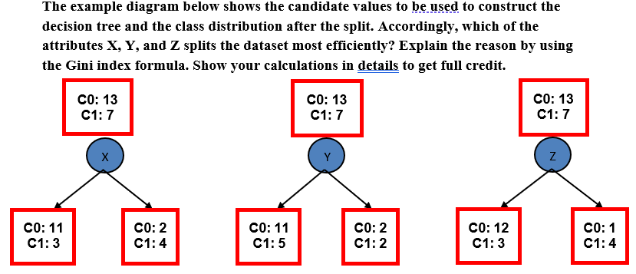

metin içeren bir resim

Açıklama otomatik olarak oluşturuldu

1. **[30 points].**

* + - * 1. (8 points).

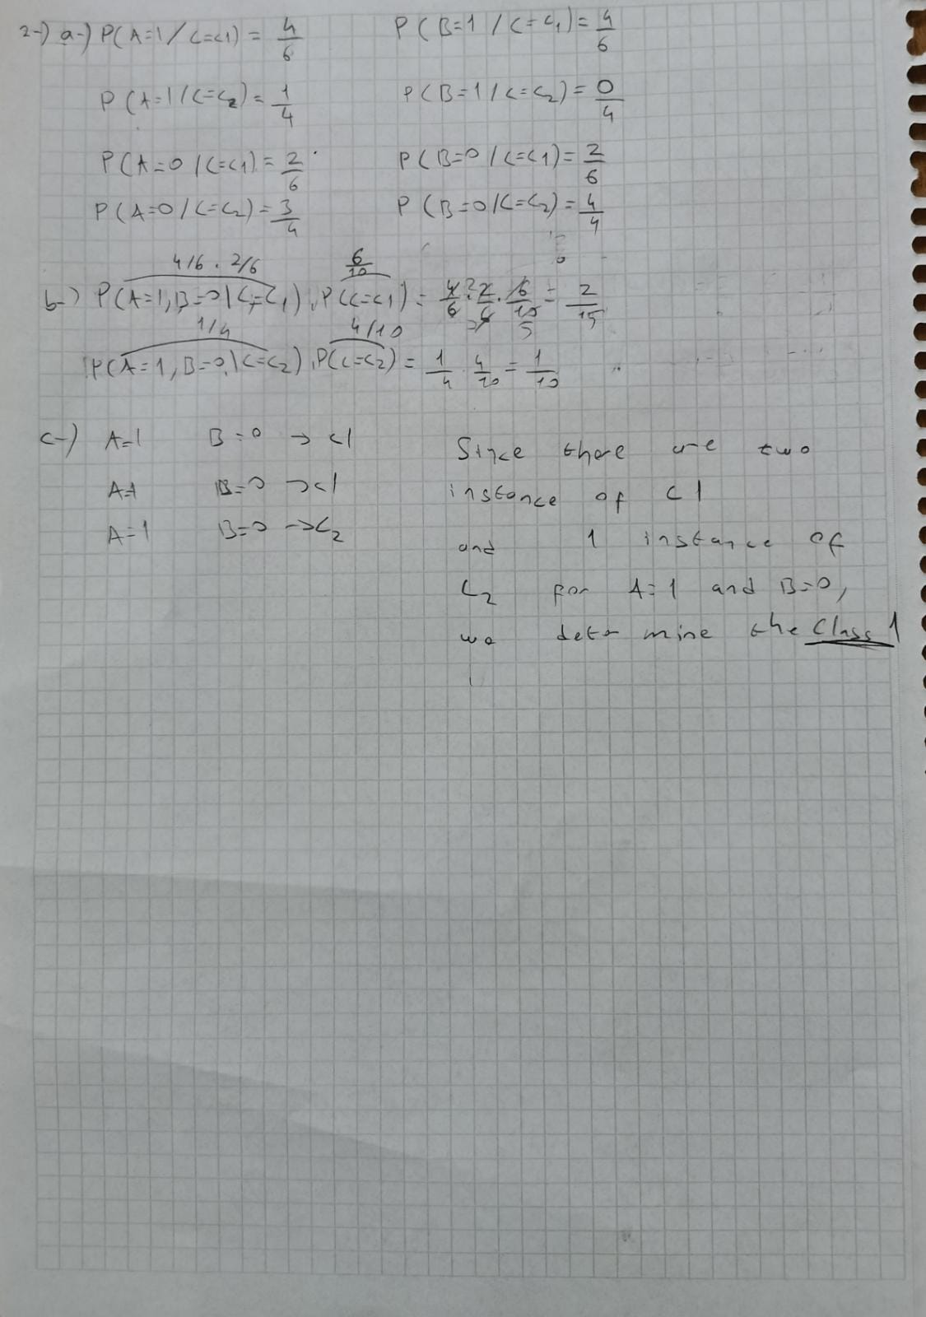

* + - * 1. (10 points).



* + - * 1. (12 points).

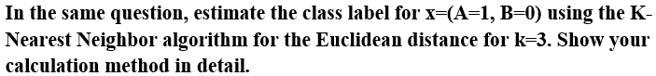

1. **[25 points].**

**Answer the following questions.**

* 1. (8 points).



* 1. (8 points).

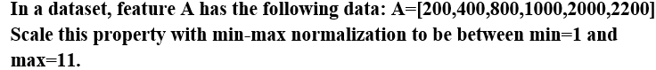

metin, mektup, harf içeren bir resim

Açıklama otomatik olarak oluşturuldu

* 1. (4 points). 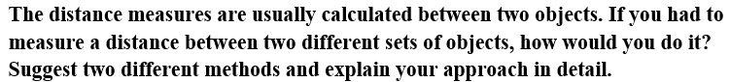

Two methods for measuring the distance between two different sets of objects are the Jaccard distance and the Hamming distance. The Jaccard distance measures the dissimilarity between two sets by calculating the size of the intersection divided by the size of the union of the two sets. The Hamming distance calculates the number of positions where the corresponding elements of two sets are different.

* 1. (5 points).

We can use line charts or heat maps to compare the performance of different servers based on CPU, memory, and disk usage data. Line charts are suitable for visualizing the changes in time series data, and we can easily compare the performance of different servers by using different lines or colors for each server. Heat maps, on the other hand, display the performance of different servers over time using color-coded cells, which can be useful for examining the overall trends across all servers.

1. **[20 points].**

metin, yazı tahtası içeren bir resim

Açıklama otomatik olarak oluşturuldu